

Lollipop Reporter

MCj04380990000[1]

June 18 thru June 22 –Art camp

July 16 thru 20 – Sports camp

August 6 thru 10 – Water camp

August 23 & 24 – Orientation days

August 27 (Mon.) – First day of school

September 3 (Mon) – No school – Labor Day

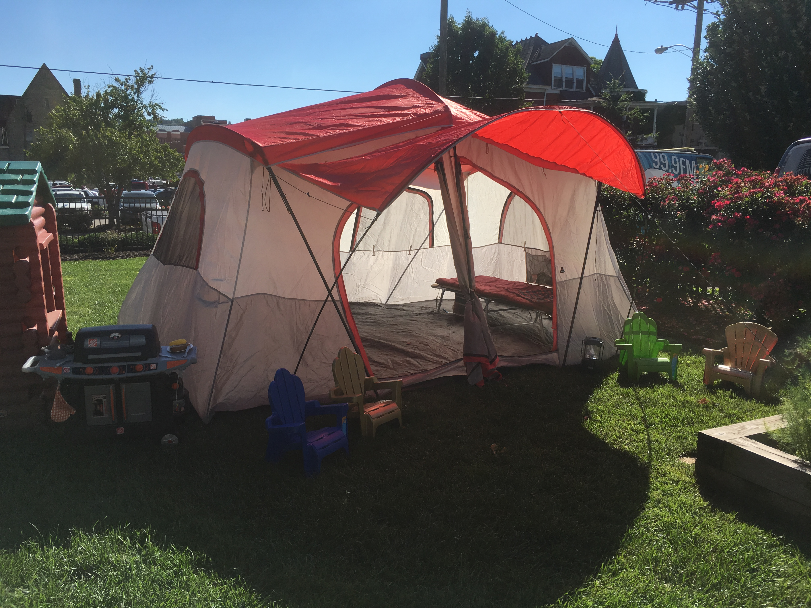

**\*\*\*\* Calendar Notes \*\*\*\*\***

**Summer 2018**

**First Presby Preschool**

16 Leon Sullivan Way

Charleston, WV 25301

**Phone:**

(304) 343-8961

**Fax:**

(304) 343-8970

**E-Mail:**

[preschool@firstpresby.com](mailto:preschool@firstpresby.com)

**Director**: Ginna Taylor

**Staff:**

Ann Grishaber

Many wonderful things are happening around the preschool this summer. There are summer camps offered, each a full week long and running from 9:00 a.m. to Noon each day. There are still openings in the camps, so if you are interested in signing up or for more information, please let us know.

We have some openings in both the Toddler and Pre-K classes, so spread the word around town. By summer’s end, it would be nice to have those classes full of new friends.

Lots of new possibilities for after school this coming year. Look for more information in the summer packet. You should receive the summer packet before the end of July. Signups for school programs will start on orientation day. Call for questions and more information.

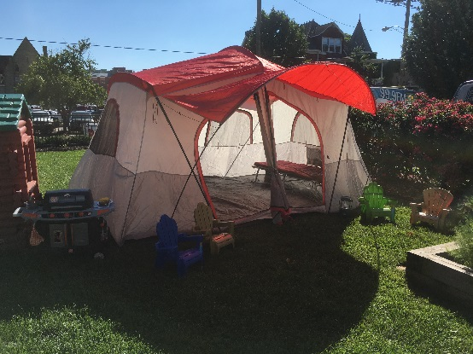

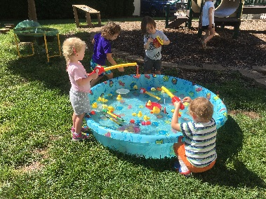

***Important Reminder***

The sun can be hot and dangerous in the deep summer months. Remember to drink water and often, wear a hat, and use sunscreen. Don’t forget our furry friends. They like to be in the air-conditioning, too.

***Individual***

***Highlights:***

Additional programs 2

Math Literacy 2

Safe fun in the sun 3

Note from Director 4

Water Play 4

**eporter**

**Lollipop Reporter**

**Page 2 of 4**

***Additional programs offered at First Presby:***

Early Drop off is available for children that have a reservation for the day. Reservations can be made at least a day in advance or can be set on an ongoing basis. Early Drop off starts at 8:00 a.m. and is $6 for each day. Lunch Bunch (for potty trained twos, three and four year olds) begins at noon and goes until 2 p.m. The children are fed lunch, rest, and then go to the playground/playroom until pick up. This is a fun, fun program for children to play and network with children from other classes.

Please call the Preschool Office for questions. We will begin sign up for these programs on orientation day.

MCj03891140000[1]



* Young children use math as they study the shape and size of different objects and as they sort materials into different categories.
* Providing young children with lots of opportunities to explore the world around them helps them to grow in math literacy.
* Throughout a child’s day, every day, point out various relationships that you see. “Look…that tree is big, but that tree is little.” It seems like such an insignificant comparison, but to a child it is a chance to form relationships, which is a foundation for math.
* Children consider shape and size, for example, as they sort and classify such natural materials as leaves, sea shells, seeds and rocks. You can encourage sorting and classifying by providing a variety of natural materials. Gather items in containers and jars and bring the experiences indoors, too. Rainy days can be a great time to sort objects inside.
* Egg cartons and other small containers can be used as sorting trays.
* As children sort materials, you might invite comments about how the materials differ from each other: how some are bigger than others, how they have different colors, how they feel different, and so on. Use all of your sensory data to help children process their world.
* Nature related activities can also be used to promote mathematical concepts related to dimensions of objects. The shape of the object is one dimension you can focus on with preschool-age children. There are shapes all around us in the natural world. Helping children describe shapes will build their observation skills and vocabularies.

Encouraging Math Literacy

in Your Child



1. Keep babies younger than 6 months out of direct sunlight. Find shade under a tree, umbrella or the stroller canopy. Remember, the sun moves across the sky, so if a youngster is under an umbrella at the beach, their shade may disappear with the movement of the sun.
2. When possible, dress yourself and your kids in cool, comfortable clothing that covers the body, like lightweight cotton pants, long-sleeved shirts and hats.
3. Select clothes made with a tight weave – they protect better than clothes with a looser weave. If you’re not sure how tight a fabric’s weave is, hold it up to see how much light shines through. The less light, the better.
4. Wear a hat or cap with a brim that faces forward to shield the face.
5. Limit your sun exposure between 10:00 a.m. and 4:00 p.m., when UV rays are strongest.
6. Wear sunglasses with at least 99% UV protection (look for child-sized sunglasses with UV protection for your child).
7. Use sunscreen. Reapply.
8. Set a good example. You can be the best teacher by practicing sun protection yourself. Teach all members of your family how to protect their skin and eyes.

**Sunscreen tips**:

Sunscreen can help protect the skin from sunburn and some skin cancers, but only if used correctly. Keep in mind that sunscreen should be used for sun protection, not as a reason to stay in the sun longer.

How to pick sunscreen:

1. Use a sunscreen that says “broad-spectrum” on the label – that means it will screen out both UVB and UVA rays.
2. Use a sunscreen with an SPF (sun protection factor) of at least 15. The higher the SPF, the more UVB protection the sunscreen has.
3. Look for the new UVA “star” rating system on the label.
   * One star is low UVA protection
   * Two stars is medium protection
   * Three stars is high protection
   * Four stars is the highest UVA protection available in an over-the-counter sunscreen product.

4. For sensitive areas of the body, such as the nose, cheeks, tops of the ears, and the shoulders, choose a sunscreen or sunblock with zinc oxide or titanium dioxide. While these products usually stay visible on the skin even after you rub them in, some now come in fun colors that kids enjoy.

Summer is great!

Ways to protect your child in the sun

**Lollipop Reporter**

**Page 3 of 4**

**er**

**Page 3 of 4**

**Page 4 of 5**

**Appropriate clothing for school**: Children in the preschool program will be involved in lots of fun activities. It is important to dress your children appropriately for school. The children will have the opportunity to experiment with paint everyday. The paint used at the preschool is washable, but be sure to send them in clothes that they feel comfortable painting in. Tennis shoes or running shoes are requested by the teaching staff. They allow the children to play comfortably on the playground and in gym. Sometimes mulch and rocks make sandals and crocs uncomfortable for children. If you have suggestions or questions about clothing for school, please let us know. We like feedback.

*On the lighter side….*

**Note from the Director**: I sometimes forget how quiet it gets around the school building in the summer when the children are gone. Ann and I look forward to having them return…they truly are the sunshine of the day. To prepare for their return, we are working on plans to add color and new equipment to the indoor playroom. We hope to surprise our students with wonderful new experiences that stimulate learning.

The teaching staff will be returning around the third week of August to begin the preparation of the rooms. Until then, we are all hoping that you have a wonderful and safe holiday.

**Lollipop Reporter**

Children learn lots from “playing” in water. Through water play, children are using critical thinking skills, practicing math, and exploring science and the environment. Water activity incorporates several different types of learning. In addition to practicing their eye-hand coordination, kids learn scientific concepts such as volume, weight, and how liquid fills different size containers. They develop language skills as they respond to open-ended questions about what they are experiencing. Critical thinking skills are improved as they predict outcomes to their water experiments. When other children are involved in the play, the children learn cooperation and socialization.

You don’t need a fancy water table or lots of equipment. You can start with some plastic bins, measuring cups, and bottles. Some other fun additions are turkey basters, strainers, eye droppers, and funnels. Pick out some of your child’s favorite water-proof toys, like plastic dinosaurs or toy dishes. Remember to always supervise your child when playing with water!

Water Play

**Page 4 of 4**

**Lollipop Reporter**

When we calculate the cost of Preschool each year, and when we set the calendar, many things happen simultaneously to make it all work. First, we begin with the calendar. Every year, we strive to provide around 160 days of student education. That is, 160 days for those students who attend five days a week. The calendar does not follow other specific calendars (like Kanawha County Schools) but is made to fit the needs of the preschool program and to facilitate needs of the teaching staff. Since many of the teachers have children that attend schools in Kanawha County, and since many of our students miss school on days that Kanawha County Schools are closed, we do observe many of the days that the County observes off. They do not all stand hard and true, so make sure that you keep a copy of our school calendar handy to know which days your preschooler is expected to attend school.

**First Presby Preschool**

16 Leon Sullivan Way

Chas., WV 25301

**Phone:**

304-343-8961

**Fax:**

304-343-8970

**E-Mail:**

Preschool @firstpresby.com

j0241037

### School calendar – How does it work?

When the budget for the Preschool is made each year, monthly allotments are made for each class grouping (i.e. two days a week or three days a week etc.). These monthly allotments are multiplied by 10 (August through May) to determine the amount of revenues that the school can depend on to balance the budget. So, your payments are based on a flat monthly amount, not a day by day basis. Some months are longer and some are shorter, but all months carry the same tuition amount. Expenses like payroll and food/supply costs are based on the calendar; that is, the number of days the children are in school. The calendar plays an important role in determining how much revenues are needed to balance the budget. If you have questions concerning your monthly rate or why the preschool is in session some days and not others, please call us. We would like to share this information and receive your feedback as well.

## My payments – How do they work?

Educating children to be creative, loving and caring individuals.

*All School Picnic – Save the Date…..August 12th @ 10:00 a.m. to 1:00 p.m.*

*Join us on the lawn of the playground for an all school picnic. Bring chairs or picnic blankets and a bag lunch, sunscreen, and lots of energy! Let’s kick off the new school year with “a time to get together”. In the event of rain, we will move indoor to the gymnasium/recreation room area.*

Abstract Artists:

Use these questions to get children thinking about art…

* How does this painting make you feel?
* What does this picture make you think about?
* What shapes can you find in this picture?
* Why do you think the artist chose these colors?

Carpool…How does it work?

Carpool is available for children in the three and four year old classes in the morning and the afternoon. Each morning, Ginna and Ann greet the children at the curb and help them from the car. They will be shown in the beginning of the year how to navigate the halls to their classrooms. We have staff inside to help guide them along the way.

At noon, one of the staff members will collect carpool number cards (you will place your number on the dash of your car), and the children will be brought out to your car by their classroom teachers.

Be patient. In the beginning, it is a learning experience for everyone.