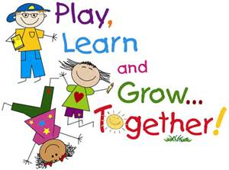
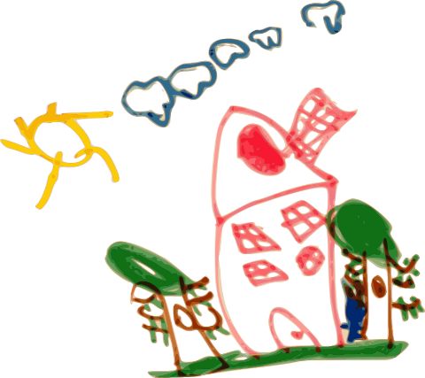
Interested in our program?? Call, email, or stop by for a tour today!! Come by for a one on one tour between 9:30- 2 Monday-Friday. Tours take you throughout the classrooms so you can see the child directed learning. Check out our Center Based learning that meets students where they are and helps them hit all developmental milestones. Call (304)-343-8961 or email us preschool@firstpresby.com We look forward to meeting with you soon.

